# CS 340 Project Two README

## About the Project/Project Title

The purpose of this project is to create a client-facing web application dashboard to present the data from the Austin Animal Center Outcomes data set. This project is build on the Model-View-Conroller model. MongoDB was selected as the model component to this project because it is free, scales well with the size of the project, can be used with all major languages, and is a powerful way to store and retrieve data quickly. Dash was used as the View component as it is a great front-end framework to present the data from the database to the users. Finally, the CRUD module (AnimalShelter.py) was used as the Controller part of the MVC design model to take user input and perform actions on the database to update the dashboard with new information. The web application allows for filtering the data in the database by allowing the users to select the filtering options as radio buttons near the top of the page. The filtering options use the CRUD module named AnimalShelter.py to interact and perform various CRUD operations in the Mongo Database that stores the data set.

## Motivation

This project is to help Grazioso Salvare by creating the client-facing web application dashboard they have requested from Global Rain.

## Getting Started

To get a local dashboard up and running a few things will need to be set up first before you run the web application. First you need to download the AnimalShelter.py and the Austin Animal Center Outcomes csv file. Next you’ll need to setup the user account inside the MongoDB shell. Once you have downloaded those two files, and set up the user account in the database, please follow along with the Installation section of the README to continue getting set up.

## Installation

Install MongoDB  
Import the Austin Animal Center Outcomes csv file using the following image as a guide:

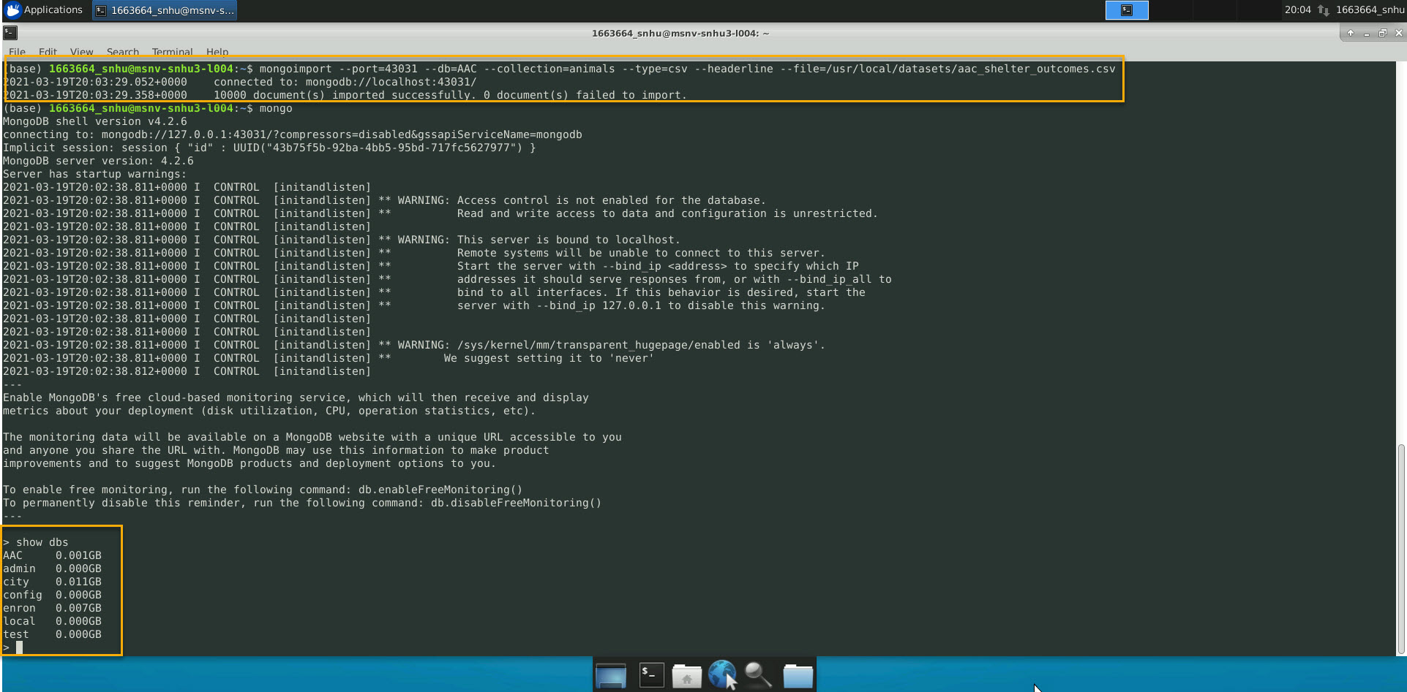

Next setup a user and an admin account using the following images as a guide:

Admin:

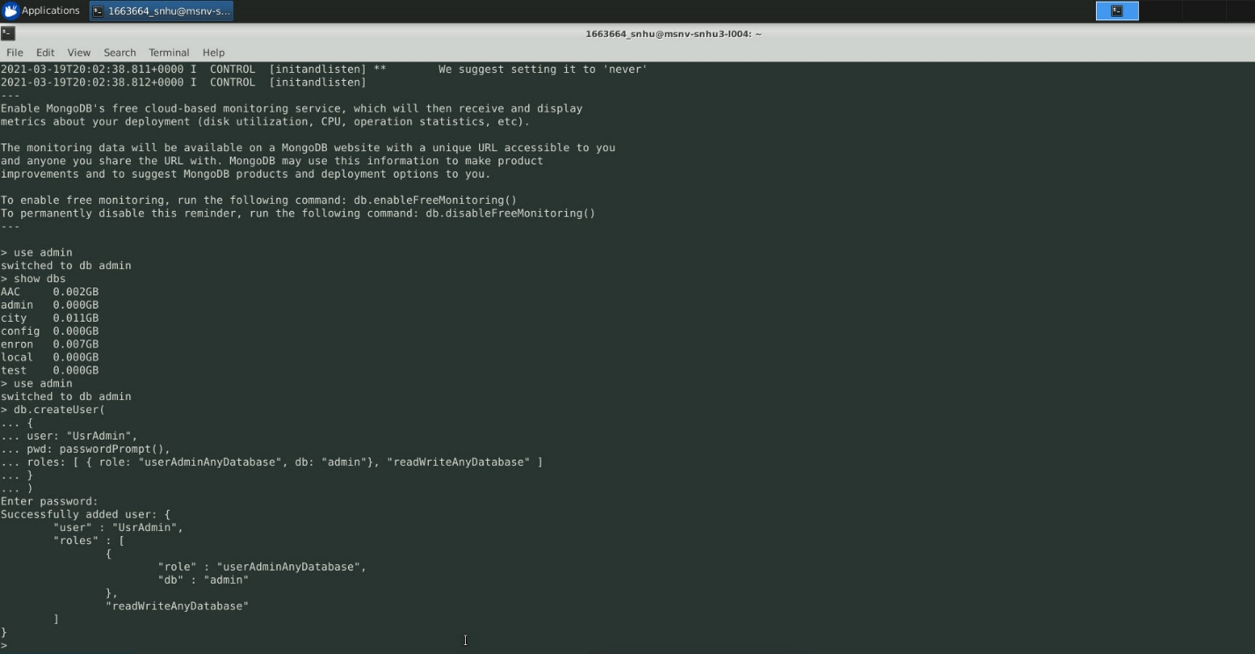

User:

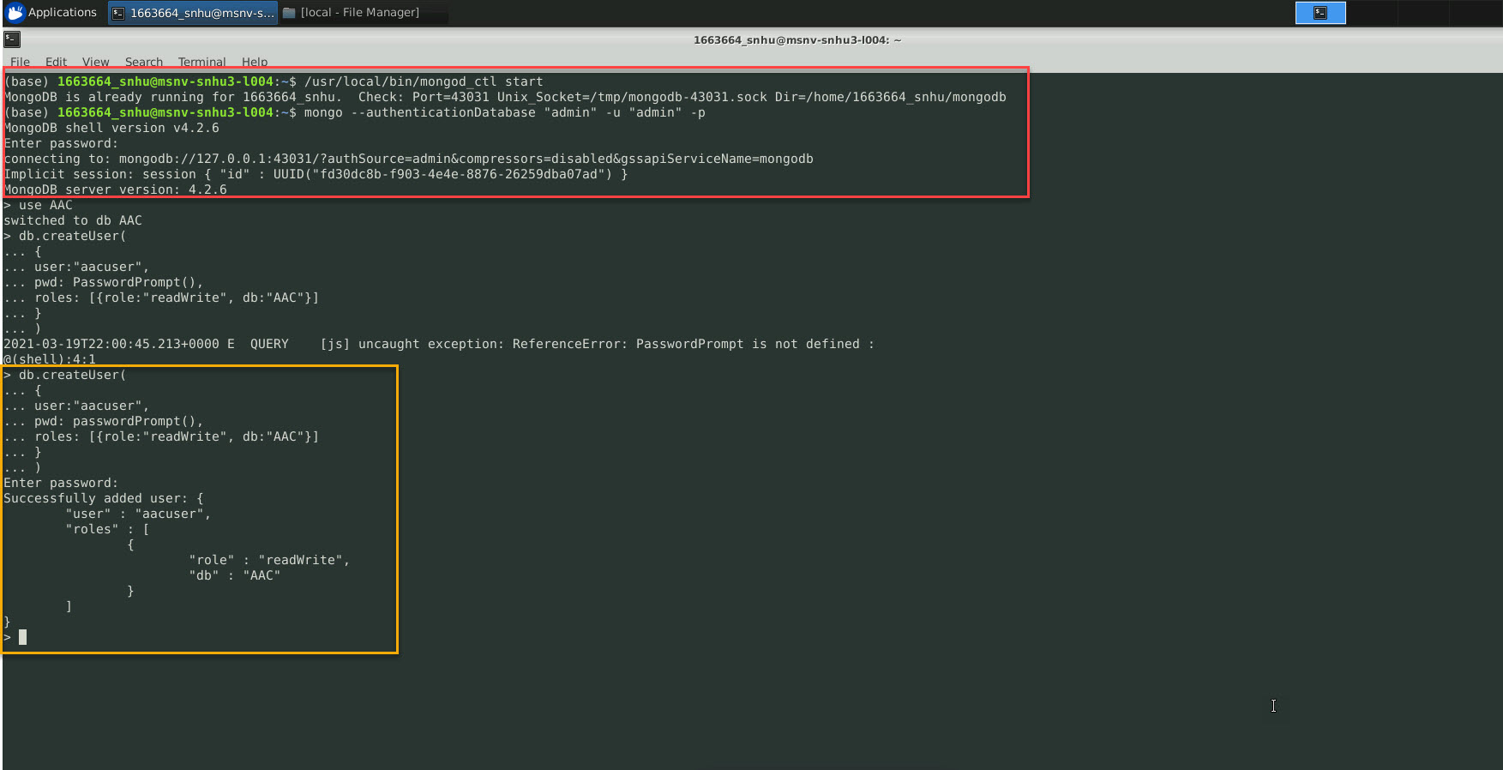

In terminal type:  
pip install pymongo  
pip install dash

pip install pandas

pip install numpy

pip install dash_table

Put the AnimalShelter.py module and the logo image file in the same directory as the dashboard’s Jupyter notebook file.  
In the Jupyter notebook file for the dashboard, you’ll need to update the username and password to be the username/password combination that you set up in a previous step.

Finally, just replace the username and password with the username and password you used to create the user account for the database and run the Jupyter notebook. Once you run the Jupyter notebook, scroll down and you’ll see a link that opens the dashboard in a new tab.

## Usage

### Dashboard Screencast



(Double click the above object to play the video)

### Dashboard Filtering Options

The dashboard filtering options are shown in the screencast example of how to use the dashboard.

## Roadmap/Features (Optional)

TODO: Figure out why the graph is not showing any data.  
TODO: Add options to change graph type dynamically.  
TODO: Update AnimalShelter.py to include more advanced CRUD operations.

## Contact

Jonathon Gaspers

[jonathon.gaspers@snhu.edu](mailto:jonathon.gaspers@snhu.edu)

**Resource Links**

[Austin Animal Center Outcomes Data Set](https://learn.snhu.edu/content/enforced/692384-CS-340-T4217-OL-TRAD-UG.21EW4/course_documents/aac_shelter_outcomes.csv?_&d2lSessionVal=8g6Xqb57stcSyHLqNhCQLAnfN&ou=692384)

[Grazioso Salvare Logo](https://learn.snhu.edu/content/enforced/692384-CS-340-T4217-OL-TRAD-UG.21EW4/course_documents/Grazioso%20Salvare%20Logo.png?_&d2lSessionVal=8g6Xqb57stcSyHLqNhCQLAnfN&ou=692384)

[MongoDB](https://www.mongodb.com/)

[Dash](https://dash.plotly.com/)